 Your name

Your age in years (Date of birth)

Click on the image icon below to upload your profile photograph

City, State, Country

Email Id, Telephone Number



Divorced / Disability / Any other Important information

Religion / Caste

Profession, Employer name

Vegetarian / Non-Veg / Vegan

List up to three hobbies / interests here

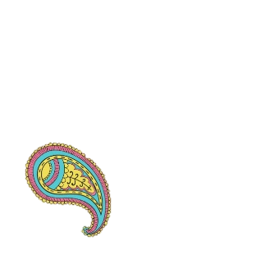

About me

Write a brief summary about your background, personality, lifestyle and interests. Here is a sample: *I am an outgoing person and I believe in making a difference to those around me. I am 32 years old and 5’8″ tall. I run my own non-profit organization that provides training to victims of domestic abuse so that they can lead an independent life. I started this initiative as I went through a brief marriage that ended in a divorce. I also dabble in painting and I am currently taking painting lessons to develop my skills. Both painting and my social activism give me plenty of opportunities to express myself and also motivate women around me to remain confident and self-sufficient.*

Expectations

Write a brief summary about your expectations from your future wife. Include details such as “must haves”, non-negotiables, interests, profession and lifestyle. *Here is a sample: If you think you can laugh at the fact that I was chased by bees every time I visited a foreign country, you are the right one for me! I am looking for a man with a pleasing personality that can keep up with my impromptu getaways. You should be willing to also put up with my dog and be open to adopting more of the four legged kind once we settle down. I am close to my parents, but they lead an independent life. I am a people’s person and expect my future husband to also embrace my family and friends as his own.*

[Create your custom biodata for marriage at Jodilogik.com](http://jodilogik.com/)

Graphics Provided by [Vecteezy.com](http://www.Vecteezy.com).